Documentation: Twitter Scrapping

1. A number of libraries are available for scrapping data from Twitter using python but due to some of the restrictions that these libraries have, we choose to go with the tweepy library.
   * Restrictions:
     + Snscrape - Not able to capture hashtags
     + Getoldtweets3 - Not working due to changes in twitter’s API
2. To start with Twitter's scraping we require a Twitter developer account which needs to be requested by applying on twitter’s developer site. The following link lists the steps required to make a Twitter developer account
   * Reference Link: [How to use Twitter Search API for beginners (sahilfruitwala.com)](https://www.sahilfruitwala.com/introduction-to-twitter-search-api)
3. Once an account has been created we start with the scrapping by first entering our credentials and modifying our query to get the desired results as seen below:

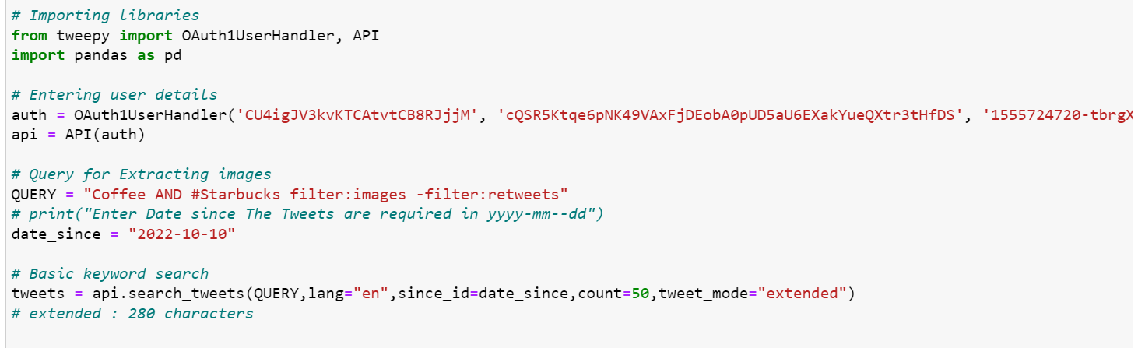

* + We also mention the date and count of tweets in the API call as parameters.
  + Reference: [Web Scraping with Python – How to Scrape Data from Twitter using Tweepy and Snscrape (freecodecamp.org)](https://www.freecodecamp.org/news/python-web-scraping-tutorial/)

1. The extracted result is as seen below:

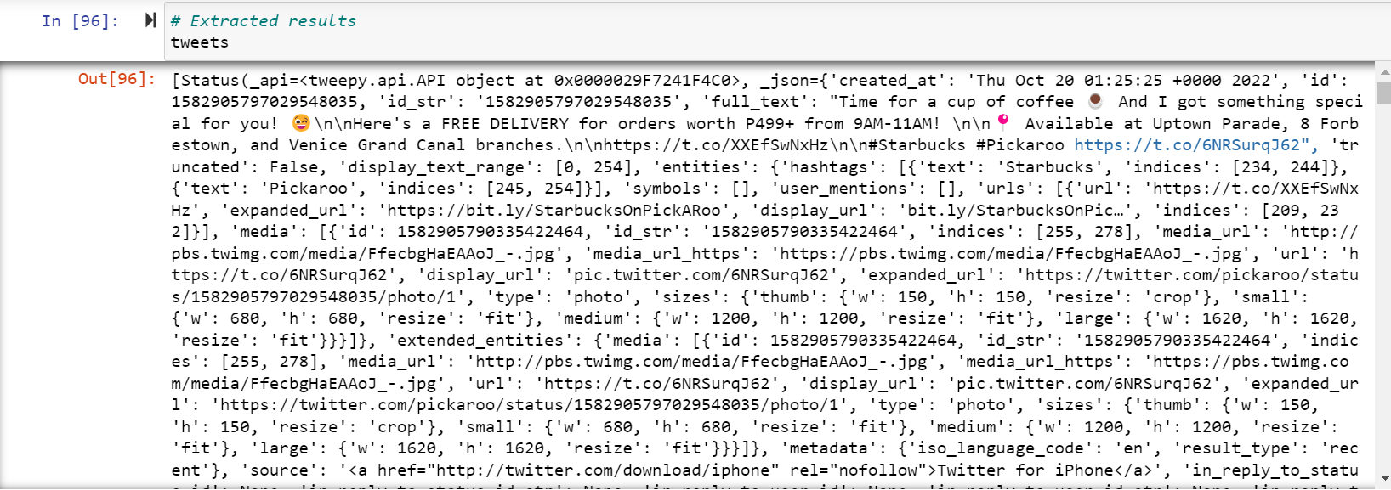

* + To better understand the different components obtained in the response we received, we convert one of the tweet's responses in to proper JSON formatting.

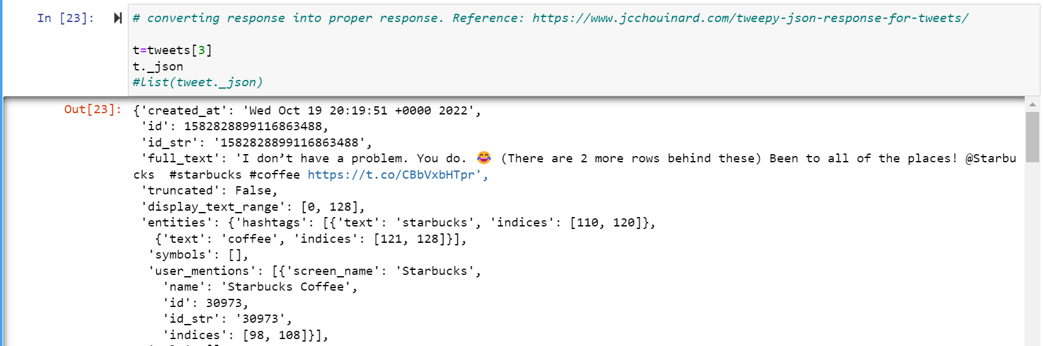

1. We then extract the required information and convert it into a data frame.

Reference: [Get data from Twitter API in Python - Step by Step Guide - Data Science Parichay](https://datascienceparichay.com/article/get-data-from-twitter-api-in-python-step-by-step-guide/)

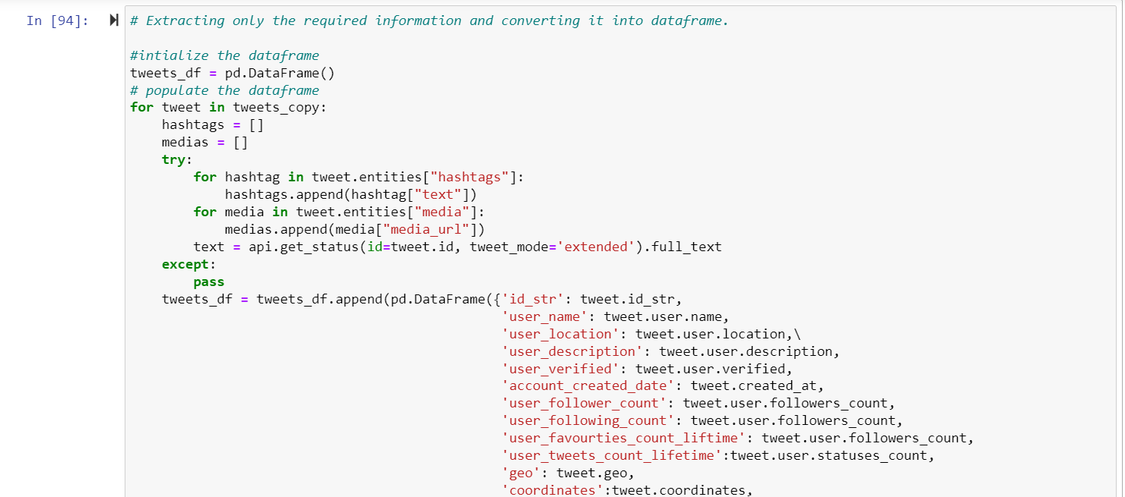

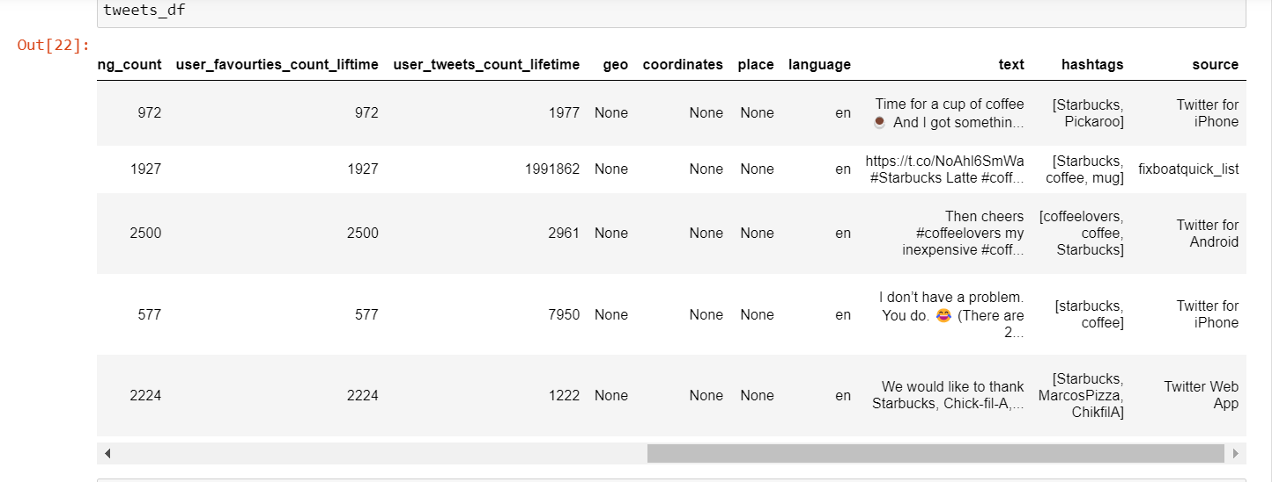

1. Once we have the metadata, we go to the next step, which is downloading the images into a local repository.

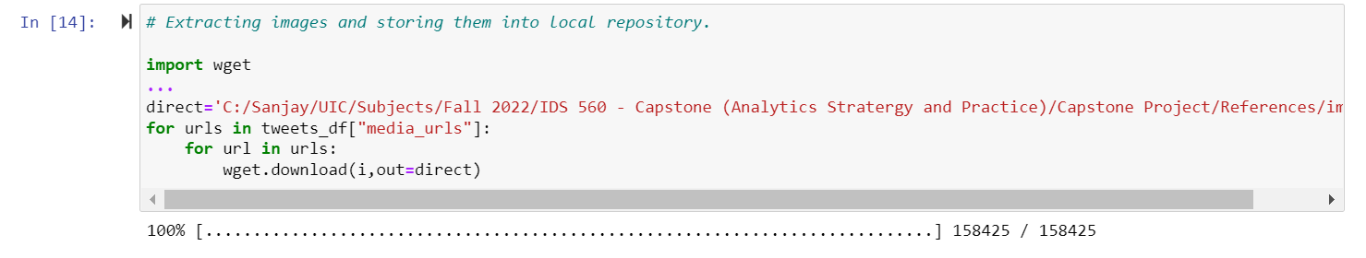

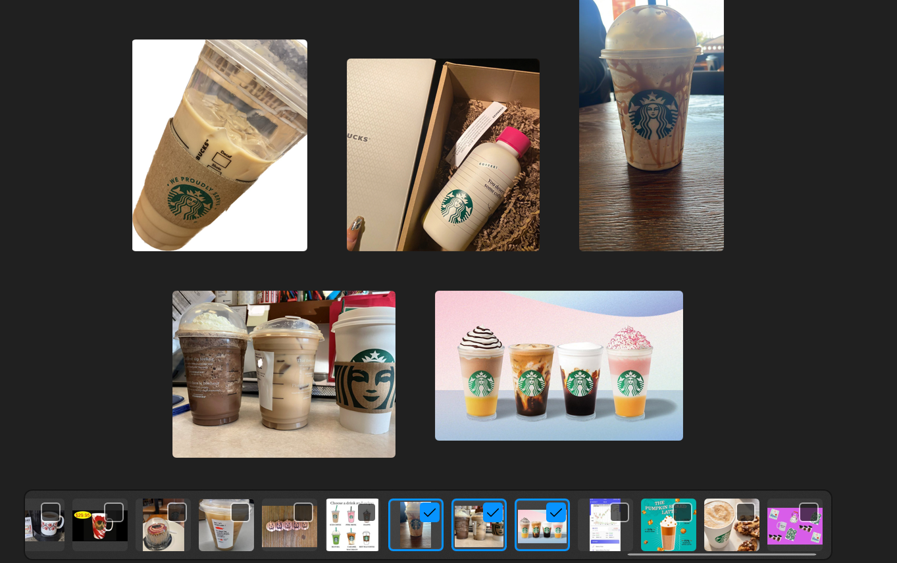

1. Converting the data frame into CSV for storage.

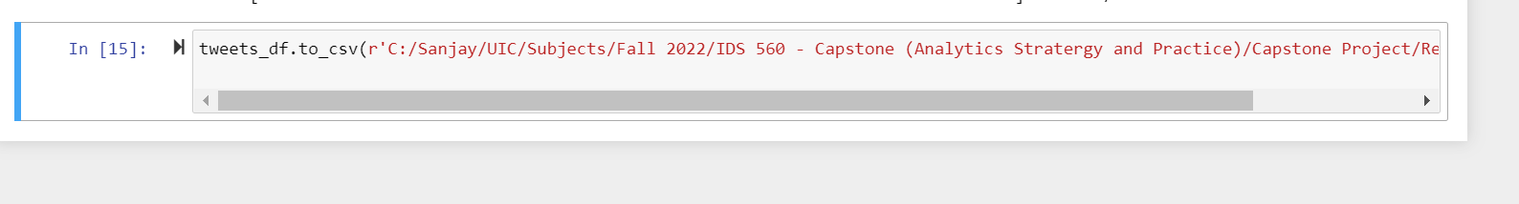

CSV File:

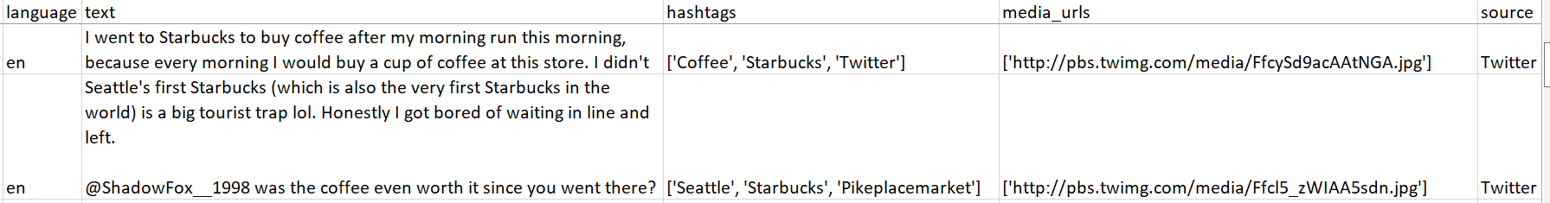

Other References used:

1. Building appropriate query:
   * How to organize your query: [Building a premium query | Docs | Twitter Developer Platform](https://developer.twitter.com/en/docs/twitter-api/premium/rules-and-filtering/using-premium-operators)
   * Filtering functions in query: [How to use Twitter Search API for beginners (sahilfruitwala.com)](https://www.sahilfruitwala.com/introduction-to-twitter-search-api)
   * Query attributes: [Standard search API | Docs | Twitter Developer Platform](https://developer.twitter.com/en/docs/twitter-api/v1/tweets/search/api-reference/get-search-tweets)
2. Image:
   * Downloading the images from tweets: [Download the pictures from a Twitter feed using Python – The Practical Academic (miguelmalvarez.com)](https://miguelmalvarez.com/2015/03/03/download-the-pictures-from-a-twitter-feed-using-python/)
3. Metadata:
   * Understanding Twitter JSON response: [Understand Tweepy's Tweets JSON Response (Twitter API) - JC Chouinard](https://www.jcchouinard.com/tweepy-json-response-for-tweets/)
   * Twitter metadata details: [User object | Docs | Twitter Developer Platform](https://developer.twitter.com/en/docs/twitter-api/v1/data-dictionary/object-model/user)